**India’s Agricultural Crop Production Analysis(1997-2021)**

**1 INTRODUCTION**

* 1. Overview
* Despite progress, Indian agriculture faces challenges such as water scarcity, soil degradation, and changing weather patterns due to climate change. These factors impact crop production and sustainability.
* The Indian government has introduced various schemes and policies to support farmers, such as the Pradhan Mantri Kisan Samman Nidhi (PM-KISAN) and the Pradhan Mantri Fasal Bima Yojana (PMFBY) to provide financial assistance and crop insurance.
* India has become a significant exporter of agricultural products, including rice, wheat, and spices, contributing to the country's economy.
* In summary, India's agricultural crop production has shown remarkable growth and diversification over the decades, but challenges related to sustainability and infrastructure persist. The sector continues to be of great importance to India's economy and livelihoods of millions of people.
  1. Purpose
* Analyzing India's agricultural crop production data from 1971 to 2021 can serve various purposes and lead to several useful outcomes:
* Policy Formulation: The analysis can help policymakers make informed decisions about agricultural policies, subsidies, and investments. It can highlight trends, challenges, and opportunities in the sector.
* Food Security: Understanding the production trends can aid in ensuring food security by identifying areas where crop production needs to be increased and diversified.
* Sustainability: Data analysis can assess the sustainability of agricultural practices, helping in the implementation of eco-friendly and resource-efficient methods.
* Research and Innovation: Researchers can use the data to identify areas where innovation is needed, such as the development of new crop varieties or pest control methods.
* Agricultural Education: Educational institutions can use the data to design curricula that are more relevant to the current needs and challenges of the agricultural sector.
* Analyzing India's agricultural crop production data offers a wealth of insights that can be harnessed to make informed decisions, improve productivity, ensure food security, and contribute to the sustainable growth of the agricultural sector.

1. **Problem Definition & Design Thinking**

This report delves into the captivating realm of India’s agricultural cultivation, providing a comprehensive visual exploration of key aspects and trends in the agricultural sector. Through the visual representations, readers can gain valuable insights into crop production, seasonal variations, regional distributions, and overall production trends. These visualizations enable intuitive analysis, allowing stakeholders to uncover patterns, identify areas of growth or concern, and make data-driven decisions.

By harnessing the power of tableau, this report not only presents the data in visually appealing manner but also provides an interactive experience for readers to explore the intricacies of India’s agricultural cultivation. To extract the insights from the data and put the data in the form of visualizations, Dashboards and Story we employed Tableau tool.

2.1 Empathy Map

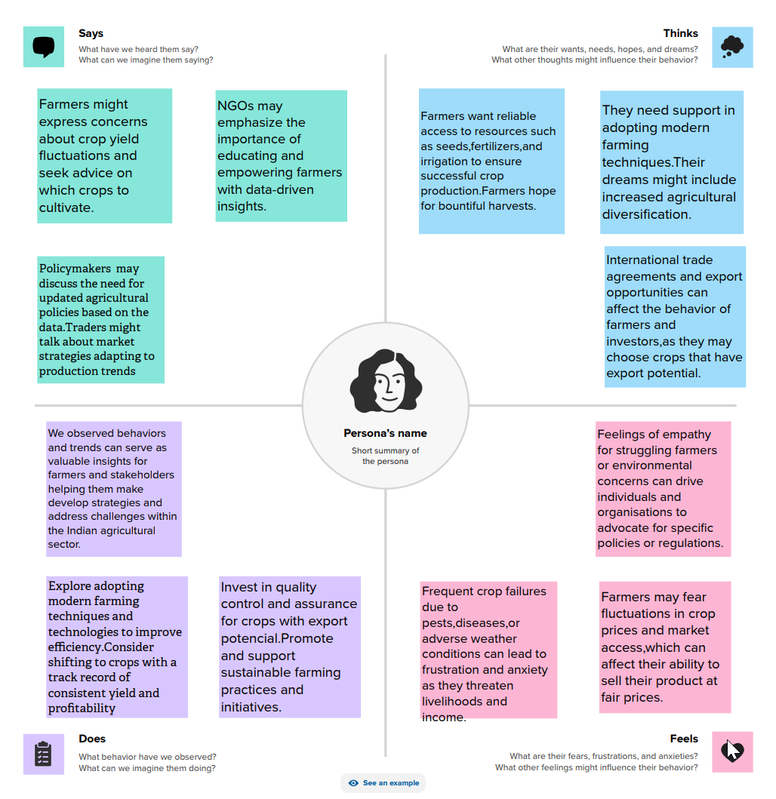

2.2 Ideation & Brainstorming Map

* Climate change impacts
* Water scarcity
* Post-harvest losses
* Soil degradation
* Infrastructure bottlenecks
* Action Items:
* Research on climate-resilient crops
* Investment in post-harvest infrastructure
* Advocacy for sustainable practices
* Policy recommendations
* Market analysis for potential exports
* Technology development for farmers

The Ideation & brainstorming map:-

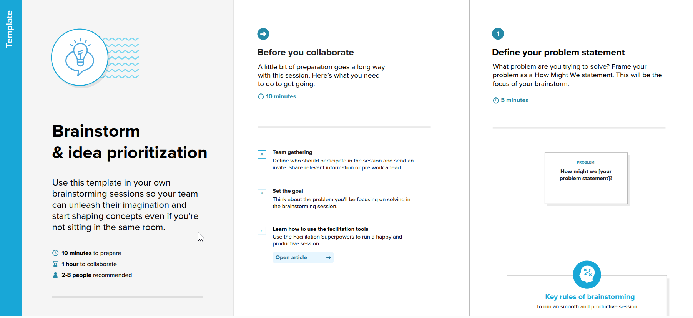



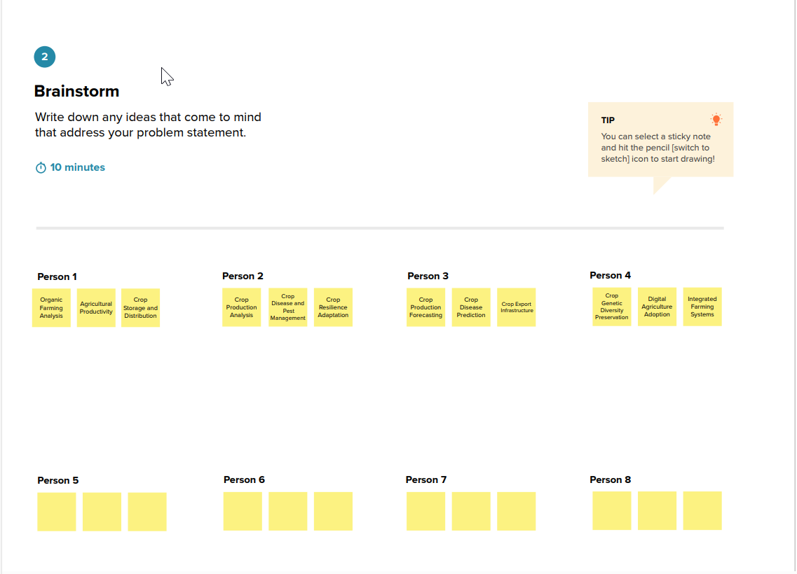

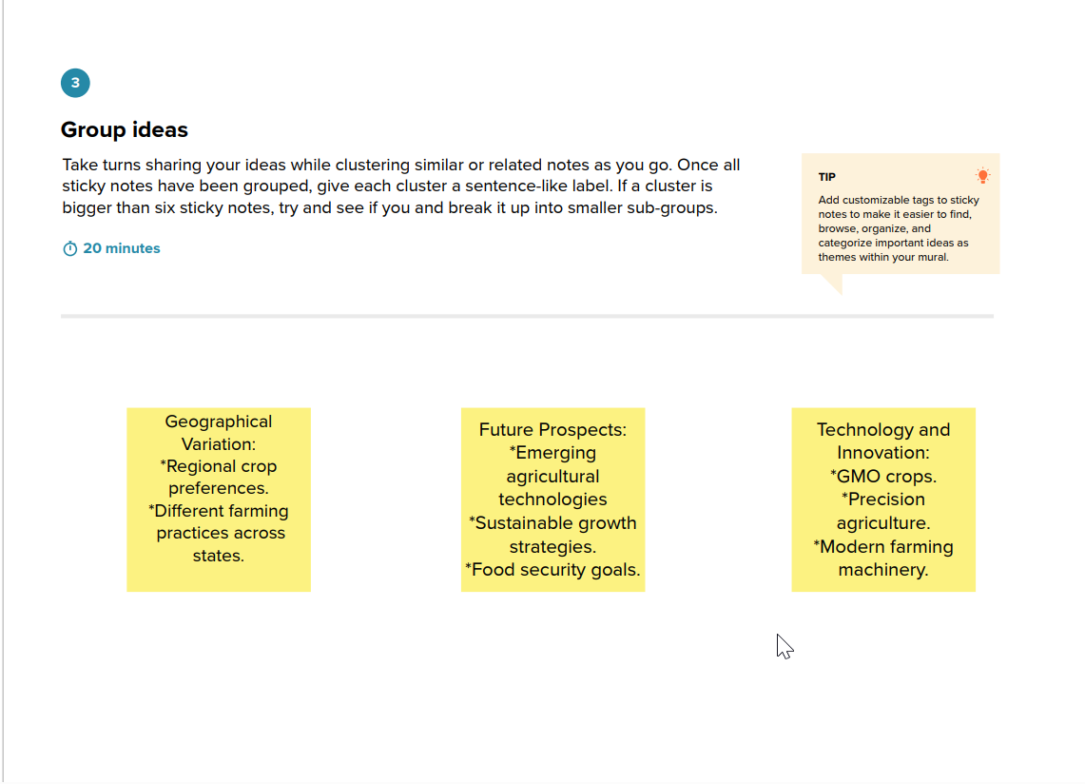

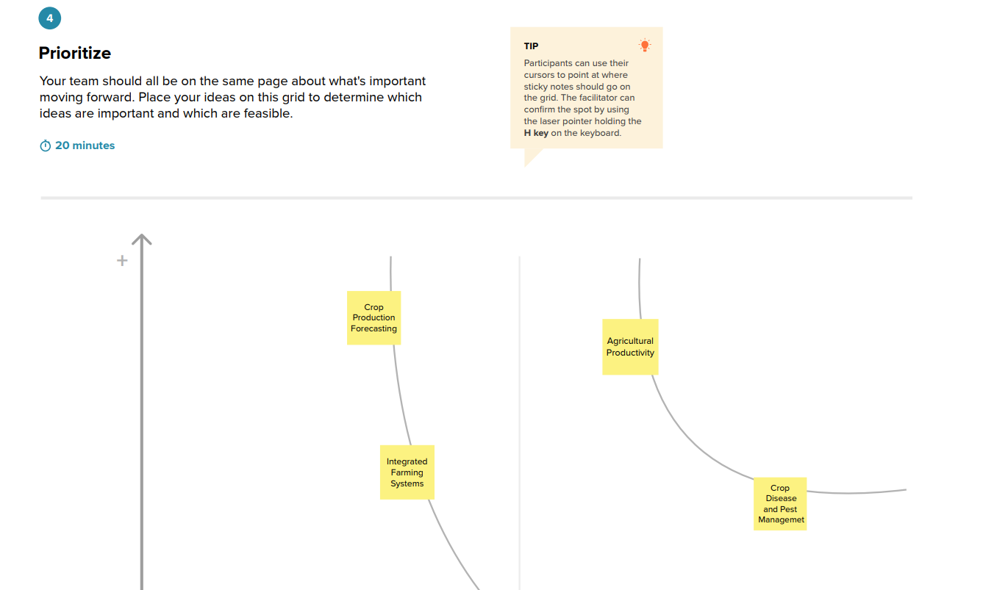

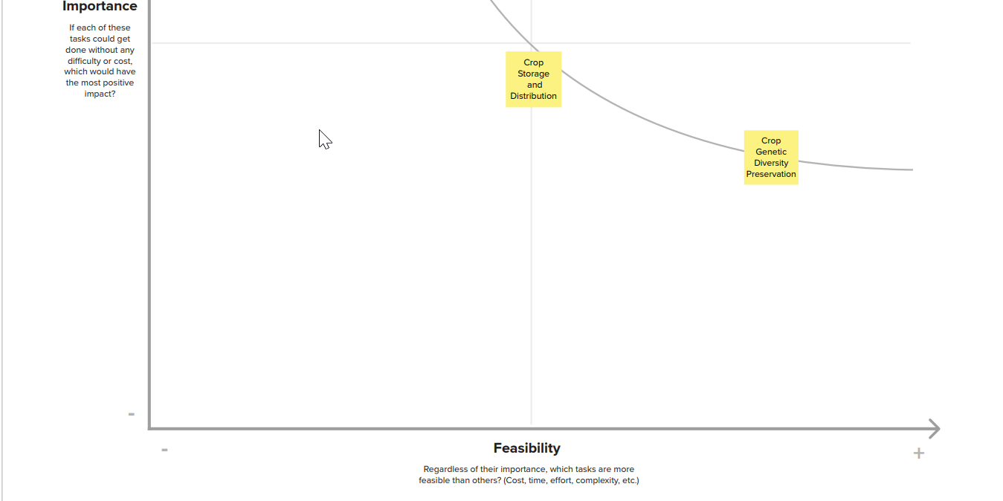

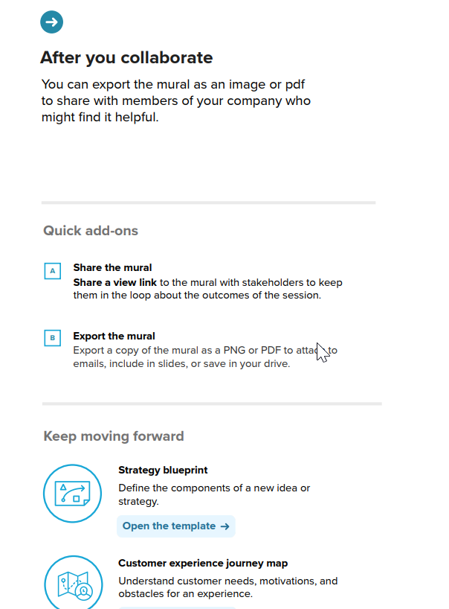



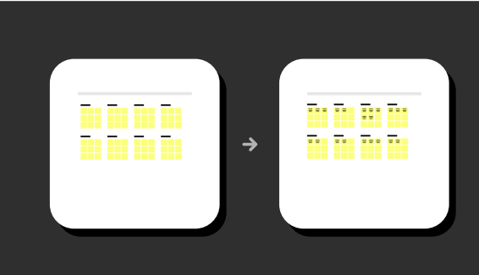

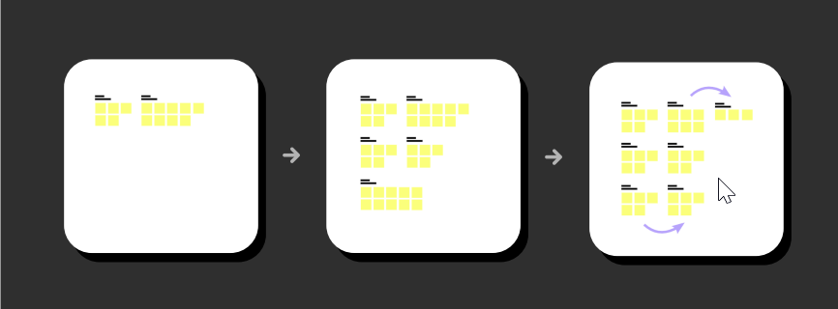

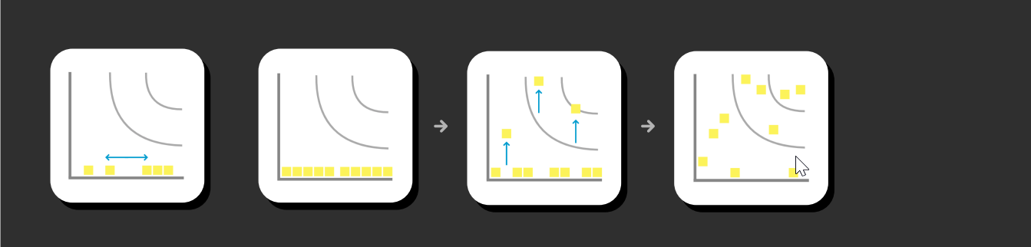

**3 RESULT**

**STORY**

India witnessed a significant increase in crop production during this period due to the adoption of high-yielding crop varieties, improved irrigation methods, and increase fertilizer use.

With economic liberalization, there was increased adoption of modern agricultural technologies and practices, leading to improved crop yields and productivity.

There was a growing emphasis on sustainable and organic farming practices , with focus on reducing chemical inputs and promoting eco-friendly methods.

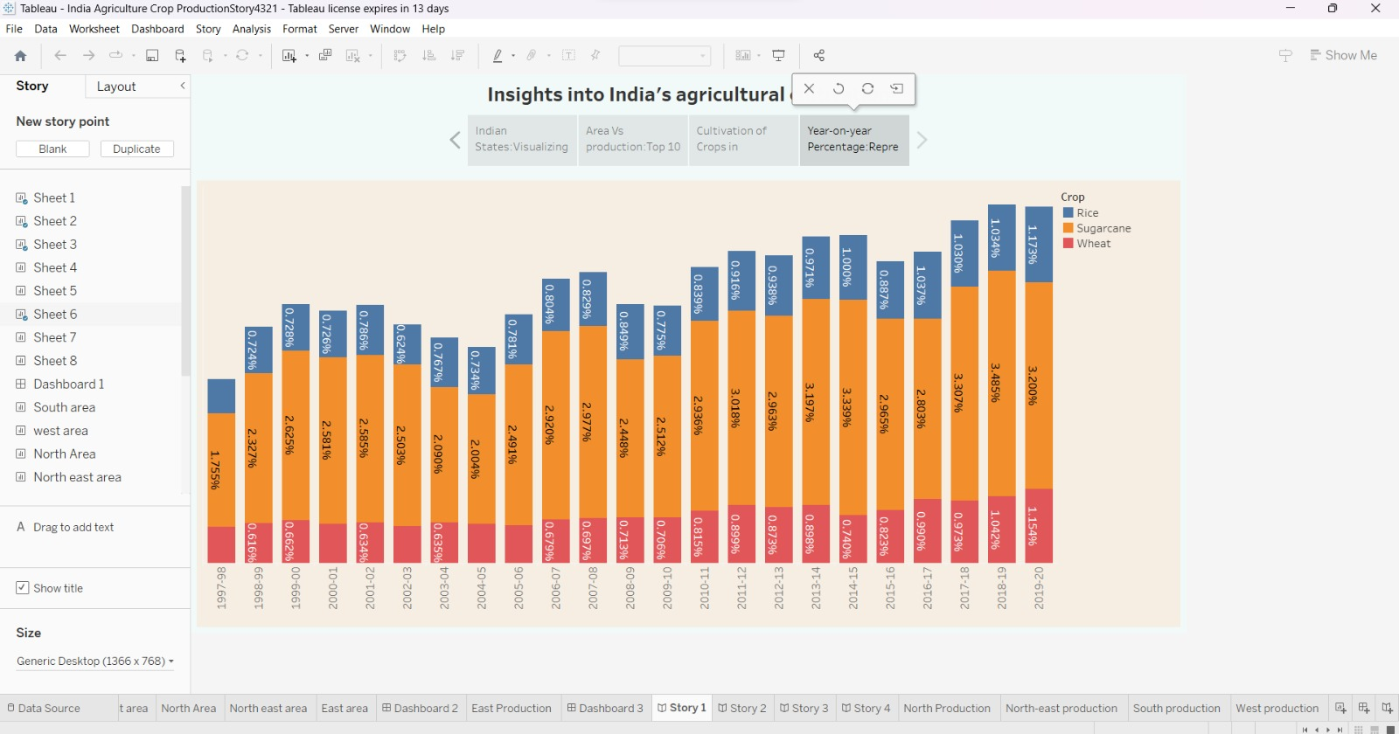

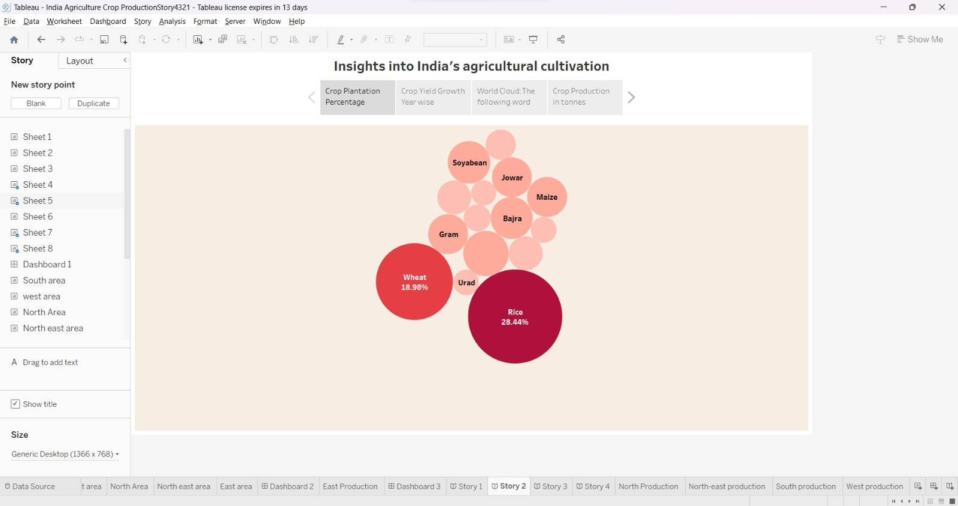

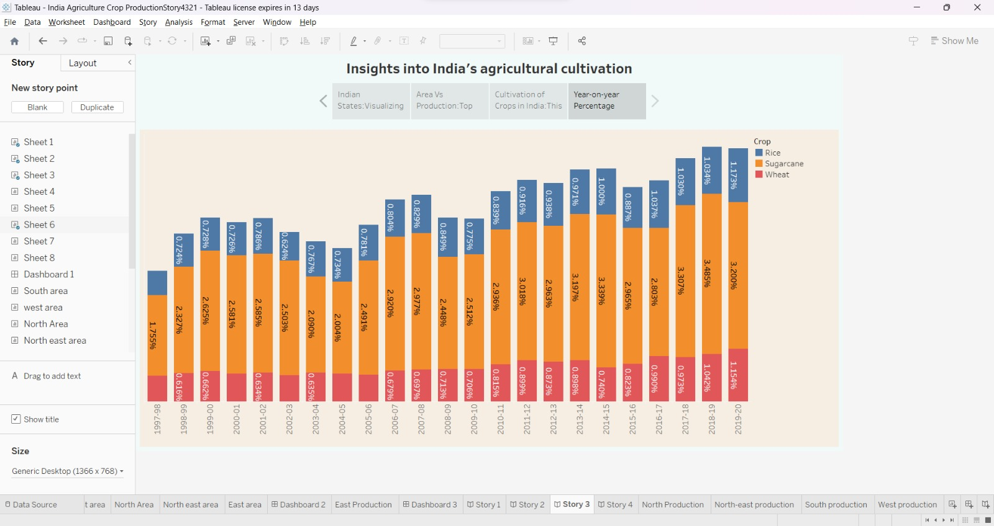

**DASHBORD**

Tableau provides various customization options for creating visually appealing and informative dashboards.

Displays the important statistics like the average yield per hetare, total production, and growth rates for selected crops and years.

Adding interactive filters and parameters, such as year selection, crop selection and region selection, to allow users to customize their analysis.

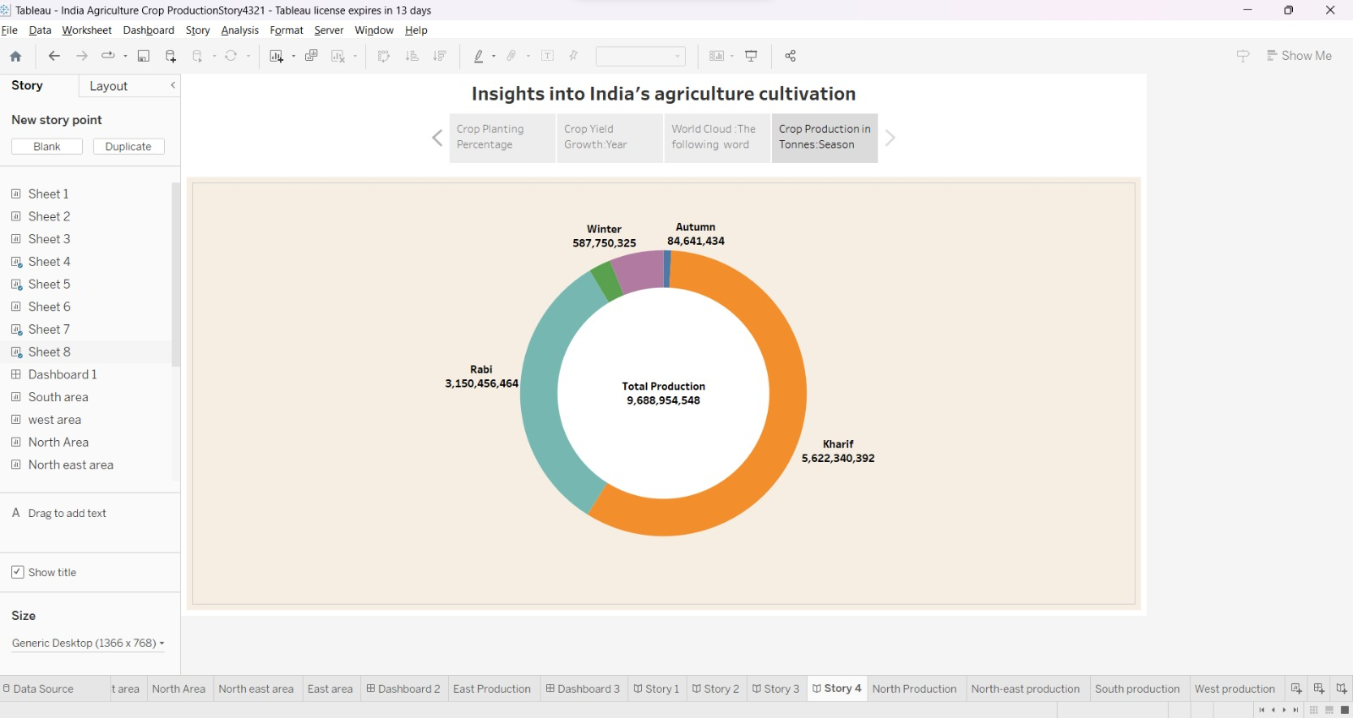

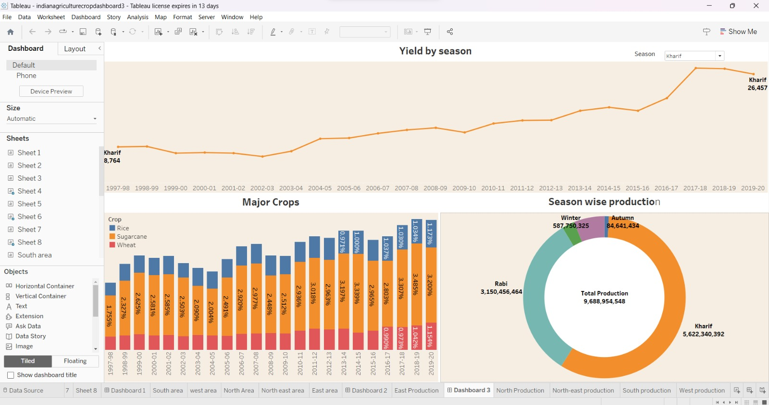

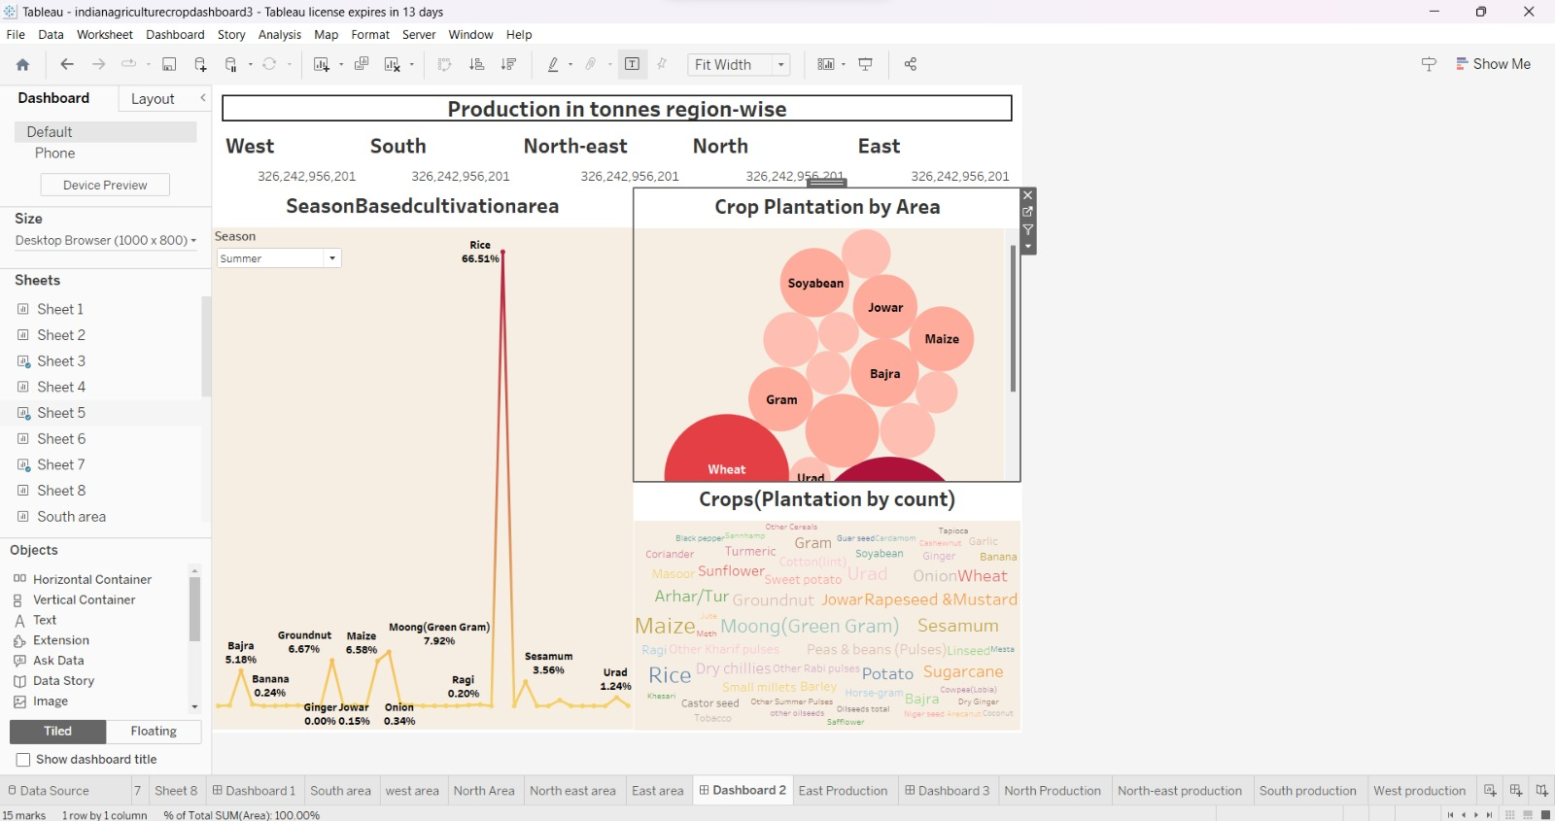

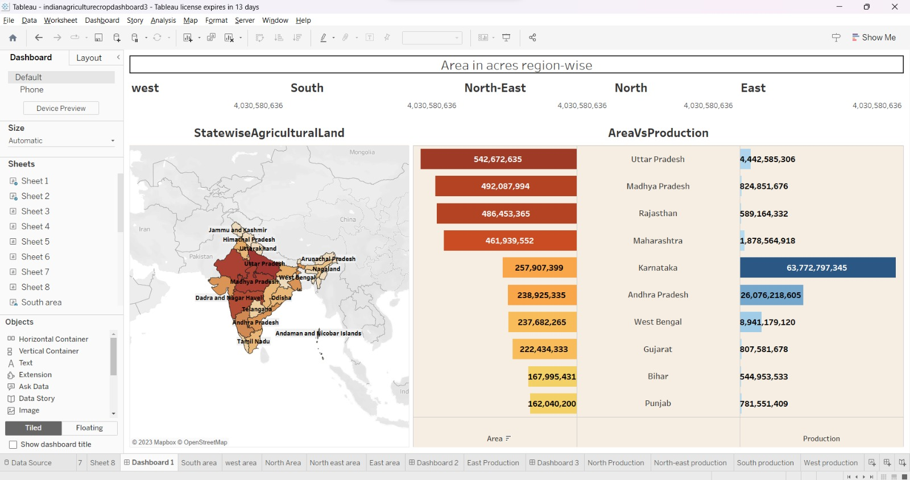

**4 ADVANTAGES & DISADVANTAGES**

**Advantages of India's agricultural crop production analysis:**

* Data-Driven Decision Making: The analysis provides a robust foundation for data-driven decision-making, allowing project leaders to make informed choices regarding agricultural policies, investments, and interventions.
* Sustainability: Understanding the historical data allows for the identification of sustainability gaps and opportunities to develop eco-friendly agricultural practices.
* Risk Mitigation: The analysis helps in identifying and addressing potential risks to agricultural production, such as climate change and environmental factors.
* Investment Prioritization: Investors can use this analysis to prioritize investments in areas with the most growth potential and align with the project's goals.

**Disadvantages: -**

* Data Limitations: Historical data may have gaps and inaccuracies, potentially affecting the reliability of the analysis.
* Changing Context: The analysis might not fully capture the rapid changes and challenges in contemporary agriculture, given the long-time span.
* Complexity: The agricultural sector is multifaceted, and analyzing data from five decades can be overwhelming, making it challenging to distill actionable insights.
* Resource-Intensive: Conducting a comprehensive analysis of this scale requires substantial resources, including time, personnel, and technology.
* Interpretation Challenges: Interpreting the data and deriving practical recommendations may be complex, and incorrect interpretations can lead to misguided actions.

**5 APPLICATIONS**

* Policy Formulation: Government agencies, at both the state and national levels, have utilized this analysis to formulate agricultural policies. It has guided decisions on subsidies, crop pricing, and support for farmers.
* Research and Development: Agricultural researchers have relied on this data to identify trends, challenges, and areas for innovation. It has contributed to the development of new crop varieties and sustainable farming practices.
* Agricultural Extension Programs: Extension services and agencies have used this analysis to educate farmers about best practices, crop selection, and climate-resilient farming techniques.
* Investment Decisions: Investors and agribusinesses have used the analysis to identify areas with growth potential and allocate resources for infrastructure, technology, and agri-startups.
* Sustainability Initiatives: Environmental organizations have applied this analysis to promote sustainable farming practices and advocate for the conservation of ecosystems and natural resources.
* Food Security Programs: The data has been instrumental in planning food security programs, ensuring an adequate supply of essential crops, and reducing dependency on food imports.
* Education and Training: Agricultural universities and institutions have incorporated this data into their curricula to educate the next generation of agriculturists and researchers.
* Rural Development: The analysis has been used to allocate resources for rural development projects, including irrigation, roads, and storage facilities, to improve agricultural infrastructure.
* In essence, the analysis of India's agricultural crop production data from 1971 to 2021 is a fundamental resource that informs and influences a wide range of activities and decisions across the agricultural sector and related fields.
* NGO and Community Initiatives: Non-governmental organizations and community groups have used this analysis to understand local agricultural dynamics, target interventions, and support sustainable livelihoods.

**6 CONCLUSION**

* Crop Diversification: India's agricultural landscape diversified during this period, with a growing emphasis on horticultural crops, fruits, and vegetables, indicating a shift in dietary preferences and market dynamics.
* Technological Advancements: Advancements in agricultural technology, including genetically modified crops and precision agriculture, have played a crucial role in improving yields and quality.
* Challenges Persist: Despite progress, the sector continues to face enduring challenges. Climate change, water scarcity, soil degradation, and post-harvest losses remain key concerns that need addressing.
* Government Initiatives: The Indian government introduced several initiatives to support farmers, including the Pradhan Mantri Kisan Samman Nidhi (PM-KISAN) and Pradhan Mantri Fasal Bima Yojana (PMFBY), which provide financial assistance and crop insurance.
* Export Opportunities: India has become a significant player in the global agricultural market, exporting products like rice, wheat, and spices, contributing significantly to the country's economy.
* Need for Sustainability: The analysis underscores the critical need for sustainable agricultural practices, given environmental concerns and the challenges posed by climate change.
* This knowledge is fundamental to shaping the future of Indian agriculture, ensuring food security, and promoting sustainable and resilient farming practices. As India moves forward, these insights will continue to be essential for the prosperity of the agricultural sector and the nation as a whole

**7 FUTURE SCOPE**

* Real-Time Data Integration: Incorporate real-time data feeds to provide up-to-date information, allowing for more immediate responses to changing agricultural conditions and challenges.
* Granular Data: Collect more granular data at the regional or district level to better understand localized trends and challenges, enabling targeted interventions.
* Satellite and Remote Sensing Technology: Utilize advanced satellite and remote sensing technology for accurate and timely information on crop health, land use changes, and weather patterns.
* Machine Learning and AI: Implement machine learning and artificial intelligence algorithms for predictive analytics, helping in forecasting crop yields, pest outbreaks, and climate impacts.
* Blockchain Technology: Explore the use of blockchain for transparent and secure data storage, enhancing data integrity and traceability in the agricultural supply chain.
* Mobile Applications: Develop user-friendly mobile apps that provide farmers with access to relevant data, weather forecasts, and best practices for their specific regions.
* Big Data Analytics: Leverage big data analytics for a more comprehensive and in-depth examination of historical data, uncovering hidden patterns and insights.
* Collaboration Platforms: Create collaborative platforms that bring together stakeholders from across the agricultural ecosystem, fostering knowledge sharing and cooperation.
* Environmental Impact Assessment: Expand the analysis to include assessments of the environmental impact of agricultural practices, aiding in sustainable decision-making.
* Education and Training: Invest in capacity-building programs to train researchers, analysts, and farmers in advanced data collection and analysis techniques.
* Public Awareness Campaigns: Raise awareness among the public about the importance of sustainable agriculture and the role of data analysis in this endeavor.